Group 3: Nobody

Group members: Caleb Corlett, Ryan Nodarse, Patrick Storer, Ethan Wyman

Project Name: Betrayal at the House on the Hill Online (Betrayal Online)

Category: Video game (web app) adaptation of a board game

*Take a deep breath before you enter. It might be your last.*

*Your fear will grow with each tile you place as you investigate a house filled with dreadful monsters and deadly secrets. As you brave your way through each unique room, you and the other explorers must rely on each other to survive the horrors that await. But beware: The house will turn one of you against the rest. It will take all of your strengths and skills to defeat the traitor and escape the Betrayal at the House on the Hill.*

**General Description:** Our project is going to be a video game adaptation of the strategy board game *Betrayal at the House on the Hill - 2nd Ed.* by Bruce Glassco.

This project will adapt the board game into a 2D web-based multiplayer game, that allows 3-6 players to enter as explorers to face the uncertainties of a haunted house. Players will choose between various characters with varying stats and histories. Players will experience events, acquire items, and face omens while exploring various rooms that are procedurally placed throughout the house.

Our application will start by showing a main menu allowing the user to start a new local-multiplayer game or view a collection of stats from previous matches. When starting a new game, there will be between 3-6 players that will each need to choose a character; the players will be able to view various stats and information of the characters before deciding on who to play. After starting the game, a turn order between the players will be decided. During a player’s turn, a player can use and interact with any items they have, or they can move their character a set number of tiles and explore open doorways. When entering an unexplored doorway, they will reveal a new room that might have the player draw either an Event, Item, or Omen card. They must react to every Event that happens, and collect every Item and Omen they find. At any point during the game, players will be able to see the effects of Events they draw, or any Items and Omens they have. Players can also view the stats of their own character and other explorers in the haunted house. When finding an Omen, there is a chance the Haunt begins. The Haunt is the second main stage of the game where one of the players becomes a Traitor and the rest become Heroes. The Traitor will use their new powers to try to kill the heroes or complete their own personal quest, while the Heroes will try to escape or put an end to the Traitor’s evil plan. After the haunt starts, if any of a player’s stats drops below the lowest level, they will die. During the haunt, any player can engage in combat to steal, deal damage, or kill other players or monsters. If you die, you are eliminated from the game. Either the traitor or the heroes will win based on their win conditions from the specific haunt that occurs in that game. After the game, players will be given stats based on their performance and will be returned to the main menu.

**App Comparison 1 - Lucidchart:**

As the explorers traverse the mansion during the Exploration Phase, they will move around tiles representing the mansion's rooms. If they enter a doorway into an area that has not been explored yet, they will draw a Floor Tile and place that tile in the area they wish to explore. Since our game will take place in a 2D environment and each of the floor tiles are squares of the same size, the explorer will place floor tiles on a grid similar to the grid-style workspace offered by the diagramming application, Lucidchart. During their move phase, if the explorer were to hover their mouse above in the unexplored section of the mansion, a shadow will appear and highlight the closest valid area for them to place a room tile.When the explorer decides on the unexplored space they wish to explore this turn, they can click their mouse and a room tile will be drawn and automatically move into place, rotating into a valid position before 2 rotation buttons will be offered to the explorer allowing them to choose which direction to rotate the room before finalizing their choice and playing out any of the room's special events.

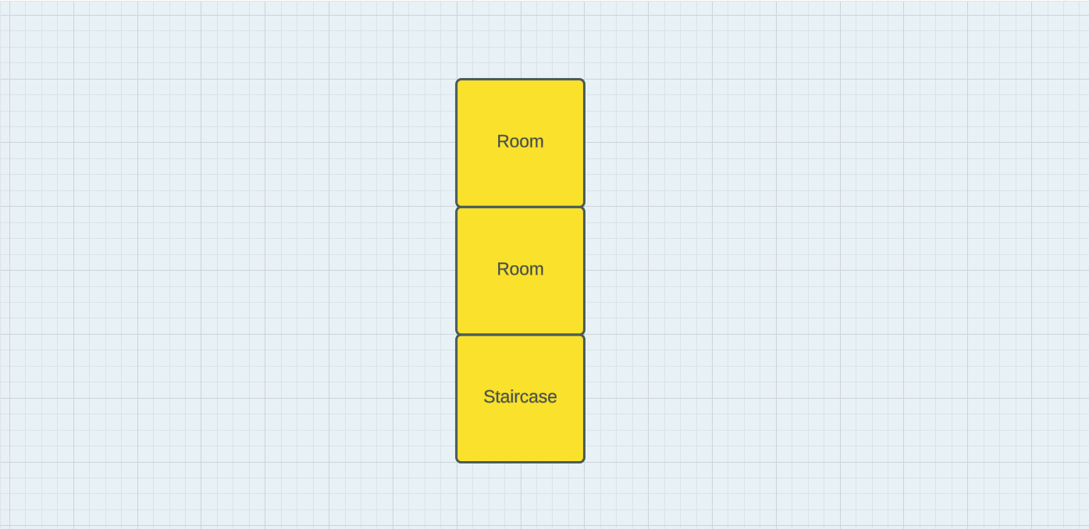

(A mockup showing how rooms tiles would sit together in a game of Betrayal. The background will not be this bright in the actual game. Made in Lucid.app)

**App Comparison 2 - Settlers of Catan:**

The map in Settlers of Catan is generated at the beginning of the game by placing several different types of tiles together, shaped in hexagons. The game requires management of resources, which is comparable to the stats that exist in Betrayal at House on the Hill. In addition, Catan has 3 types of cards that can have major effects on the game, some of which can be utilized at the user’s discretion. However, Betrayal will have varying objectives, whereas the objective of all players in Catan is identical and remains the same throughout the game. In Betrayal, the goal of each player is determined when a certain event (The Haunt) happens, which allows for more variability in gameplay. Additionally, Betrayal will have a three-floor map, which will require a unique way to view the different floors.

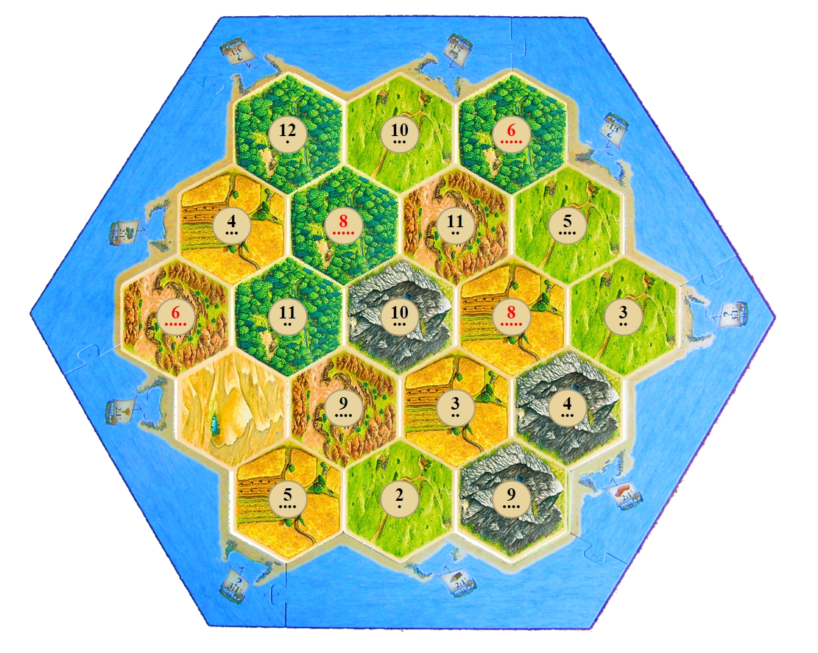

**App Comparison 3 - Monopoly:**

While players are exploring through our exploration phase they open new rooms with certain events that may trigger the player to attain an item. When the player obtains the item it may be hard for the player to remember all of the items they have and what they do hence the player would need an inventory of sorts to help them keep track of their items. One game that is also a board game that uses cards for information that I thought of was the board game Monopoly where the players earn houses through purchases that collect rent from other players however the more expensive the place the more the rent is therefore you need to keep track of the amount owed to you from other players. Players playing Betrayal will need to manage and keep track of their stats and items constantly so having to constantly remember such knowledge is a huge task therefore having a U.I. with the information or specifics of our owned cards so that we can review the cards at will and make adjustments to our game as needed.

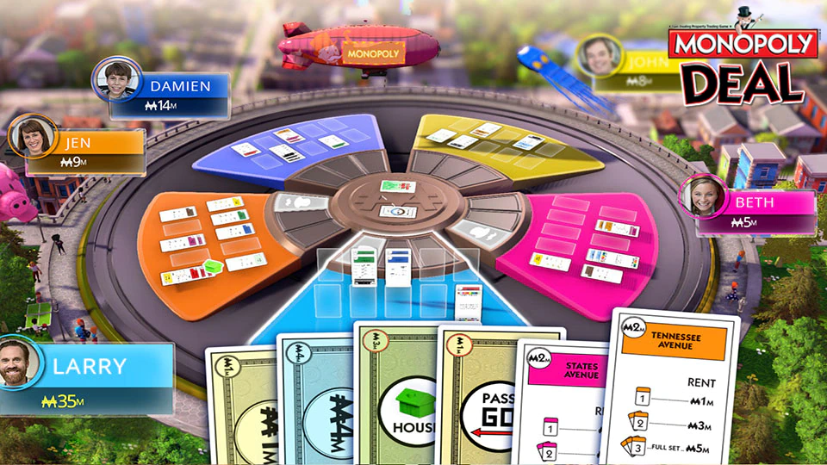

(Monopoly Online Ubisoft games)

Monopoly keeps their cards simple and informative which is probably something we will do however these cards will take up a bigger portion of the screen U.I. so one thing that I think should differ from the Monopoly game would have an inventory tab that the player could click on providing them a new menu with their owned items so that they can keep track of what they have.